Linking information

In the ETCS concept location based information is given as a distance from a BG. This is for this specific information the “original reference BG”.

Location based information has to be compared with the actual location of the train which is available in reference with the last detected BG (further called the LRBG).
Therefore the distance between all BG's which have sent location based information and the LRBG has to be known. The chain of BG's which is build this way is further called a “linking chain”.

The distance between the BG's is either known
- from messages giving the distance from a specific BG (further the “linking reference”) to other BG('s) (further referred to as “D_BG_LINK”) and/or
- by measuring the distance using information coming from the odometer (further referred to as “D_BG_ODO”) and odometer inaccuracies (inaccuracy between two BG's: D_BG_UNDEREST(IMATE) and D_BG_OVEREST(IMATE))
The information sent to give the distance between BG's is further called “linking distance”. This information is normally sent before the BG('s) to which a distance is given are reached, but can also be sent after passing those BG('s).
If new “linking distances” are sent, all already available linking distances in advance of the “linking reference” are replaced, i.e. a BG can never be announced with more than one “linking distance”.

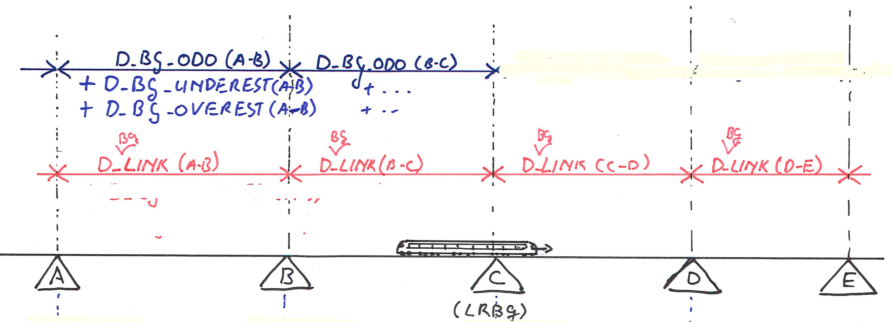
Figure 1: A simple “linking chain”

Together with the “linking distance” to a BG, also the following information is given:
- The location inaccuracy of the “announced BG”. This inaccuracy is the inaccuracy of the absolute position of this BG. The given “linking distances” are the distances between the nominal positions both from the sending (or referenced) BG and the announced BG.
- The passing direction of the “announced BG” is given.
- The reaction required from the OBU if the BG is not detected according to the announcement is given (the “linking reaction).
Together the “linking distance”, the “location accuracy”, the “passing direction”, the “linking reaction” and the “identity of the BG” to which the “linking distance” is given, are further called the “linking information”.

NOT YET ANNOUNCED AND UNLINKED BG'S
Not all BG's are announced. All BG's indicate if they are “linked” (i.e. “linking information” is available track side). A linked BG is normally announced before it is detected. However in special situations (start of mission, after deleting information,...) no linking information may be available on-board. In those cases the information coming from the linked (but not yet announced) BG shall be used, and linking information for the BG may be received (and shall than be used) afterwards.
If there is linking information available on-board and a BG marked as “linked” is detected while it is not included in the linking information, then this BG shall be ignored (i.e. the on-board shall react as if the BG had not been detected).

“Unlinked BG's” can be used in between a chain of linked BG's. For those BG's the distance to other BG's is only known by measuring data coming from the odometer:

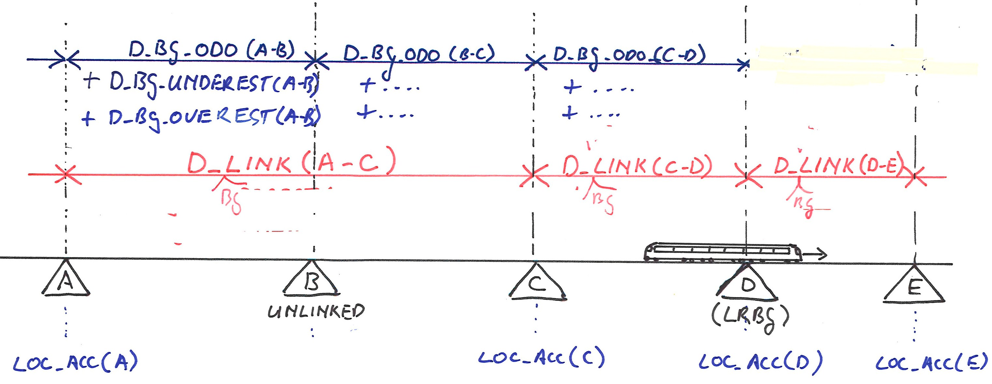
Figure 2: A linking chain containing an unlinked BG
Question: is a “location inaccuracy” (LOC_ACC) used for unlinked BG's??

LINKING HOLES
A special type of “linked” BG's are the “repositioning BG's”. Those BG's are used track side when more than one route is possible and the actual route is not known to the sender of the “linking information” (e.g. if the sender is a fixed BG). When a “repositioning BG” is announced the exact distance to this BG (and further BG's) cannot be given because several routes are possible. Therefore for one or more BG's the distance between the BG's will be missing. Such missing information is further called a “linking hole”.

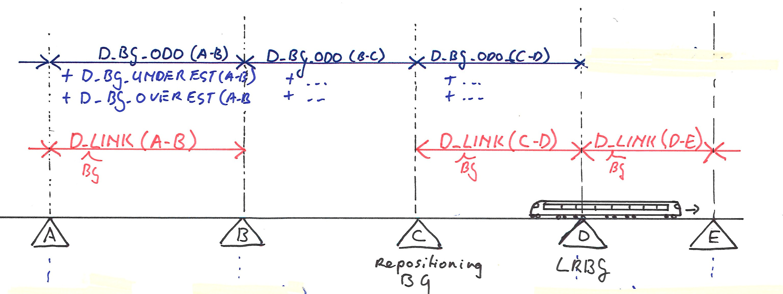
Figure 3: A linking chain containing a “linking hole”

INACCURACY OF LOCATION BASED INFORMATION
The location based information is given for an exact distance from the nominal position of the “original reference BG”. However the “original reference BG” may have been installed at a slightly different position (the location inaccuracy of a BG: “LOC_ACC”). This leads to a tolerance in the distance from the reference BG to the given location:
For each location the maximum distance that it can be closer and the maximum distance that it can be further from the “original reference BG” are equal to the maximum inaccuracy in the position of the reference BG (“LOC_ACC”).

The maximum inaccuracy of the linking distance between two BG's is the sum of the inaccuracies (LOC_ACC) of both BG's.

Distance to location based information, measured from the LRBG
All location based information is given in reference to a BG in rear of the train. The BG which was used as reference location for specific location based information is further called the “original reference BG” for that specific “location”.
The current train location is known in reference to the LRBG.
To compare the “locations” with the “current train location”, for all “locations” the distance from the LRBG to the “location” shall be calculated. However the calculation is equal for all “locations” with the same “original reference BG”. Therefore the calculations shall be done per remembered BG.

Aspects (of the remembered BG's) to be calculated to determine the distance between the LRBG and locations with an “original reference BG” being “A”:
- Distance between “A” and the LRBG
The distance between “A” and the “locations” (D_LOCATION) which have “A” as the “original reference BG” shall be reduced with the distance between “A” and the LRBG. This distance is further called: “D_BG-LRBG” {distance between original reference BG and LRBG}
This distance can either be measured (odometer) or be calculated from the linking information (if available)
- The uncertainty in the distance between the LRBG and locations with “A” as “original reference BG”
The uncertainty in the distance between the LRBG and a “location” is equal for all locations with the same “original reference BG”.
The maximum distance the location can be closer to the LRBG is further called D_MAXCLOSER
The maximum distance the location can be further from the LRBG is further called D_MAXFURTHER
The uncertainty in the distance depends on the way D_BG-LRBG is determined (measured or calculated).
As D_BG-LRBG and the uncertainty in the distance between the LRBG and the “location” are the same for all “locations” sent by one “original reference BG”, the corresponding variables (D_BG-LRBG, D_MAXCLOSER and D_MAXFURTHER) can be calculated and stored per remembered BG.

CALCULATING DISTANCE AND UNCERTAINTY BASED ON LINKING INFORMATION (if available), figure 4
- The distance between the “original reference BG” and the LRBG can be calculated by adding all linking distances in the “linking chain” between the “original reference BG” and the LRBG. I.e. D_BG-LRBG = ∑ linking distances
- The uncertainty in the distance between the LRBG and a “location” is equal to the location inaccuracy of the LRBG. This because the nominal distances between the BG's and the distance to a “location” are all exact. I.e. D_MAXCLOSER = D_MAXFURTHER = LOC_ACC(LRBG)

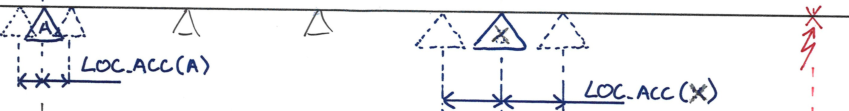
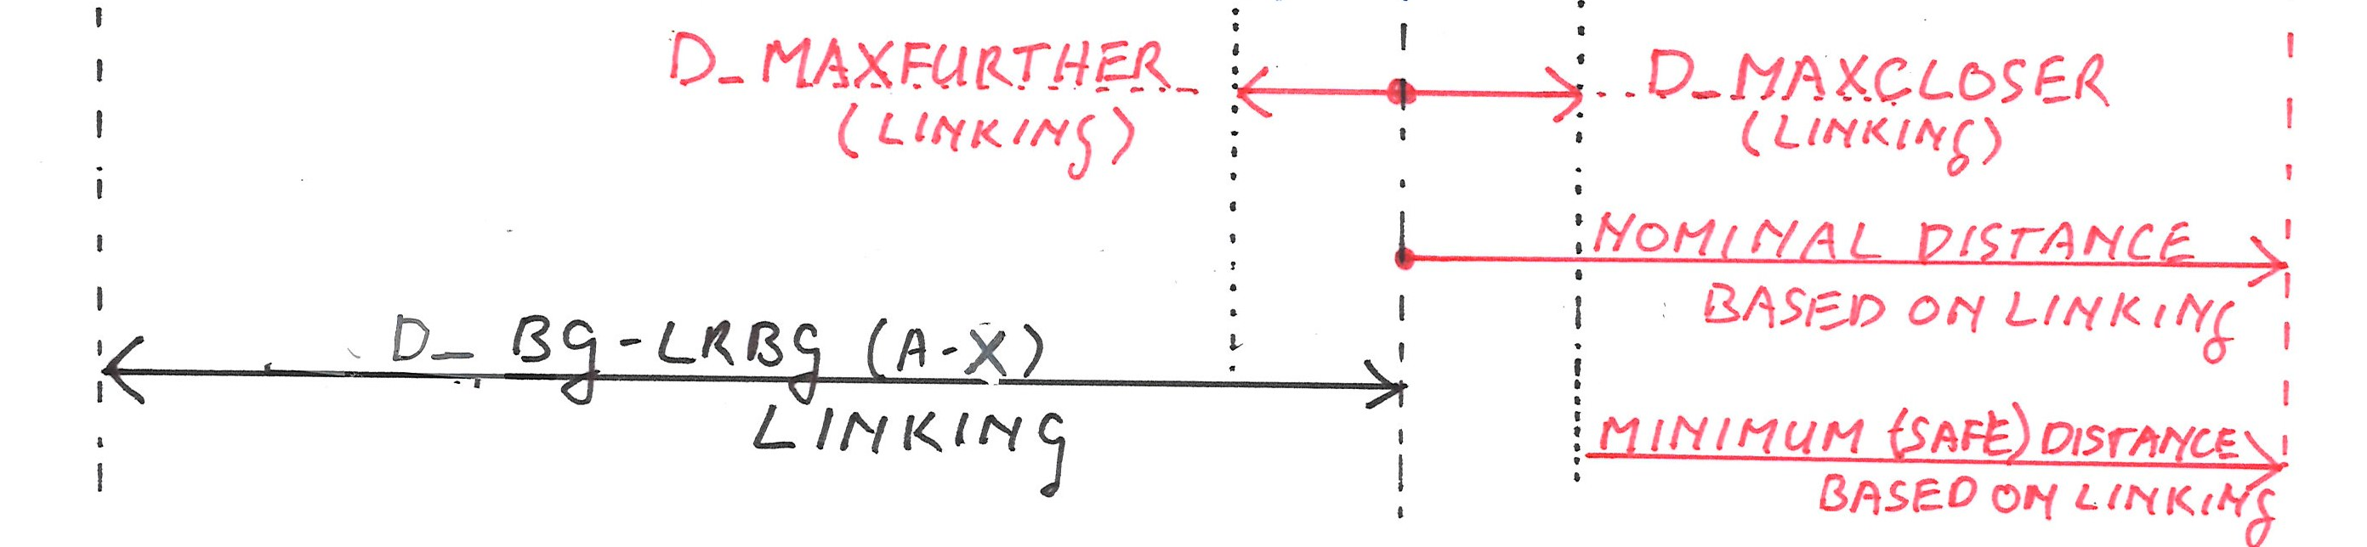
Figure 4: Calculating the distance between the LRBG and a “location” based on linking

CALCULATING DISTANCE AND UNCERTAINTY BASED ON MEASUREMENT, figure 5
- If no linking information is available, or measuring the distance leads to a less restrictive distance to a “location” then the distance between the “original reference BG” and the LRBG shall be measured. I.e. D_BG-LRBG = the nominal distance measured between detecting the “original reference BG” and the LRBG.
- The uncertainty in the distance between the LRBG and a “location” is equal to the odometer inaccuracy between detecting the “original reference BG” and the LRBG plus the location inaccuracy of the “original reference BG”. I.e. if the “original reference BG” is “A”:
- D_MAXCLOSER = D_BG_UNDEREST. (A-LRBG) + LOC_ACC(A)
- D_MAXFURTHER = D_BG_OVEREST. (A-LRBG) + LOC_ACC(A)

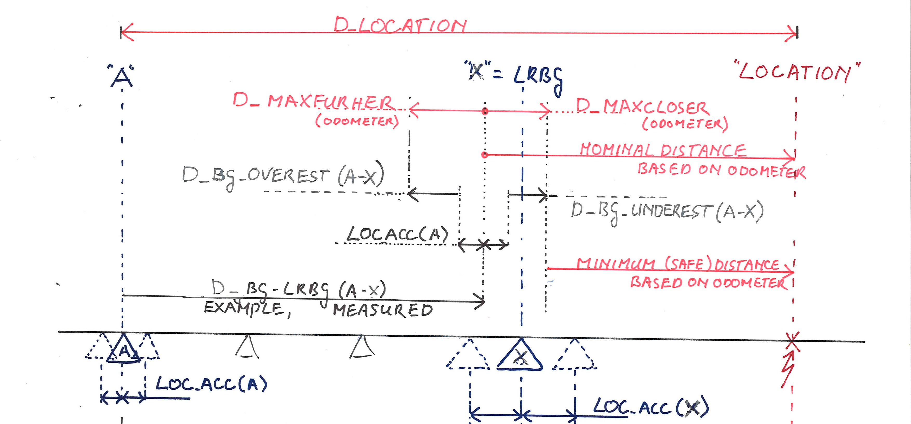
Figure 5: Calculating the distance between the LRBG and a “location” based on measurement (arbitrary example)

When the locations are calculated as a distance from the LRBG the tolerances can change with every new LRBG due to differences in the location inaccuracy of the BG's, missing linking information and/or odometer inaccuracy. To avoid shortening of the “minimum safe distance” to a “location” when a BG is detected, the least restrictive method (calculation based on linking or measurement) shall be used. The algorithm to do this is described below for three situations:
- All linking information is available
- The linking chain includes one or more “linking holes”
- The linking chain includes one or more “unlinked BG's”

ALGORITHM for linked BG's without “linking holes” in the chain (all linking information is available)
Whenever a new BG is detected and becomes LRBG, for all already passed stored BG's the distance between the BG and the LRBG (D_BG-LRBG) and the uncertainty for the positions which have the BG as “original reference BG” (D_MAXFURTHER and D_MAXCLOSER) shall be updated.

The criterion to be used is:
When a new LRBG is detected the “minimum safe distance” to the “locations” shall not be shortened.

The “minimum safe distance” just before detecting the new LRBG was (see figure 4 and 5):
D_LOCATION - D_BG-LRBG (previous!) - D_MAXCLOSER - the maximum safe distance travelled since detecting the previous LRBG.

The “minimum safe distance” when the new LRBG is detected and linking information is used:
D_LOCATION - ∑ (linking distances from the “original reference BG” to the new LRBG) – the location inaccuracy (LOC_ACC) of the new LRBG.

If the “minimum safe distance” to the “locations” is shortened (compared to the “minimum safe distance” just before detecting the new LRBG) when the new LRBG is detected and linking information would be used, then
- the calculation of the new values for D_BG-LRBG, D_MAXCLOSER and D_MAXFURTHER shall be based on the previous values for D_BG-LRBG, D_MAXCLOSER and D_MAXFURTHER and the distance travelled since passing the previous LRBG (taking inaccuracies into account!), else
- the calculation of the new values for D_BG-LRBG, D_MAXCLOSER and D_MAXFURTHER shall be based on the linking distances from the “original reference BG” till the new LRBG.

ALGORITHM for linked BG's with “linking hole(s)” in the chain
A “linking hole” is a part of the “linking chain” for which no linking information is available. Two situations in which “linking holes” can appear are taken into account:
- The “linking chain” includes a repositioning BG sent with an identity “unknown”. In this case the distance between the BG before the repositioning BG and the repositioning BG is not known exact.
What shall be done with the linking distance given for a repositioning BG? D_LINK does not have a special value.
- The “linking information” for a number of BG in rear of the LRBG has not (yet) been received. It has to be taken into account that this information will be received afterwards.
However it is assumed that no “linking information” will be received for BG's in rear of a linking hole (in rear of the LRBG).

The calculation of the distance between the LRBG and “locations” shall be done as if there are no “linking holes” in the “linking chain”, using the measured distance instead for the “linking holes” (taking the measurement inaccuracy into account!).

ALGORITHM for linked BG's with “unlinked BG's” in the chain
If unlinked BG's are installed between linked BG's then the linking chain is interrupted. However the unlinked BG's can be ignored when calculating the linking distance from linked BG's to the LRBG.

If the new LRBG is an “unlinked BG” the measured distance from the last linked BG to the new LRBG shall be used in stead of the linking distance (taking the measurement inaccuracy into account!).

For an unlinked BG only the measured distance and measurement inaccuracy for the distance till the LRBG have to be remembered.

Summary of data to be stored
A list of passed BG's shall be stored. At every detection of a new LRBG and reception of “linking information” for BG's in rear of the current position this list shall be updated.
To enable the above described calculations the following information shall be stored per linked BG:
- The inaccuracy of the positioning of the BG: LOC_ACC (also for unlinked BG's??)
- A link to the previous linked BG, further called the “previous linked BG in the chain”.
- The linking distance from the “previous linked BG in the chain” (thus not being an unlinked BG): D_BG_LINK
- A link to the previous BG, further called the “previous BG in the chain”.
- The measured absolute position (an absolute position from the odometer of the distance travelled since start up) at which the BG was detected. S_BG_ABS
- The measured distance from the previous BG: D_BG_MEASURED
- The maximum overestimation of the measured distance from the previous BG, i.e. the distance that locations are further away from the train (add up in MAX_FURTHER): D_BG_OVERESTIMATED
- The maximum underestimation of the measured distance from the previous BG, i.e. the distance that location are closer to the train than measured (add up in MAX_CLOSER): D_BG_UNDERESTIMATED
- The passing direction.
- A marker indicating that the BG is “linked” (and can thus be used in communication to the RBC).
- A marker indicating if the BG is a “repositioning BG” for which the linking distance is not exact”
correct ???
- Distance to the furthest location given by the BG: to determine if all locations given by the BG are passed, thus the BG can be deleted (unless there are less than 8 BG's in memory
Further the following calculation results shall be stored:
- The calculated and/or measured distance between the BG and the actual LRBG: “D_BG-LRBG”
- The determined distance “locations” which have the BG as the “original reference BG” can be closer to the LRBG than nominal: D_MAXCLOSER.
- The determined distance “locations” which have the BG as the “original reference BG” can be further from the LRBG than nominal: D_MAXFURTHER.

The distances between BG's can be calculated from the “measured absolute position”

The distance between the LRBG and a BG whose location based information is all in rear of the train is not relevant. Therefore BG's can be forgotten if all locations referred to are in rear of the train. Together with the maximum amount of data to be sent and the rules for replacing data this gives a maximum to the number of BG's to be remembered. This maximum is reported in TO BE DEFINED.

Per unlinked BG the following data shall be stored:
- The inaccuracy of the positioning of the BG: LOC_ACC (also for unlinked BG's??)
- The measured absolute position (an absolute position from the odometer of the distance travelled since start up) at which the BG was detected. S_BG_ABS
- The measured distance from the previous BG: D_BG_MEASURED
- A marker indicating that the BG is not “linked” (and can not thus be used in communication to the RBC).
Further the following calculation results shall be stored:
- The measured distance between the BG and the actual LRBG: “D_BG-LRBG”
- The determined distance “locations” which have the BG as the “original reference BG” can be closer to the LRBG than nominal: D_MAXCLOSER (which is the maximum under estimation of the distance travelled from the BG to the LRBG).
- The determined distance “locations” which have the BG as the “original reference BG” can be further from the LRBG than nominal: D_MAXFURTHER (which is the maximum over estimation of the distance travelled from the BG to the LRBG).

A list of announced BG's shall be stored with the same data as already passed linked BG's, except the measured distances and calculated/measured distance to the LRBG

Per “location” the identity” of the “original reference BG” (NID_C and NID_BG) shall be stored together with the distance between the “original reference BG” and the “location” (D_LOCATION).

Principles for handling information
As all “positions” with the same “original reference BG” have the same correction distance and uncertainty when referred to the LRBG, the concerning variables only have to be stored once (in the data structure describing the remembered BG). The information only has to be recalculated if a new LRBG is detected and if new linking information is received concerning the LRBG or BG's in rear of the LRBG.

If a functions requires a “location” in reference to the LRBG (and possibly the uncertainty of the position) then a function related to the position shall be available to calculate the required information from D_LOCATION and the values D_BG-LRBG, D_MAXCLOSER, D_MAXFURTHER stored for the “original reference BG”. Those values shall be available for all stored BG's

If linking information is received in rear of the LRBG (or concerning the LRBG) then the data can be stored in the data structure describing the BG('s) just as it is done when the data is received before reaching the BG's. The new data will be taken into account when recalculating

Locations shall be sorted per type (MA, speed limit, gradient,....) in the order in which they will be reached. This shall be done after every reception of a new LRBG and reception of linking information for BG's in rear of the LRBG.
Possibly not all calculations have to be done in the same cycle (e.g. minor updates only for the first xx km during the current cydle).

If the LRBG is an unlinked BG, it shall not be used in communication to the RBC. For communication the last detected linked BG shall be used.
To be calculated from the stored absolute position (absolute distance since SoM: D_BG_ABS).

